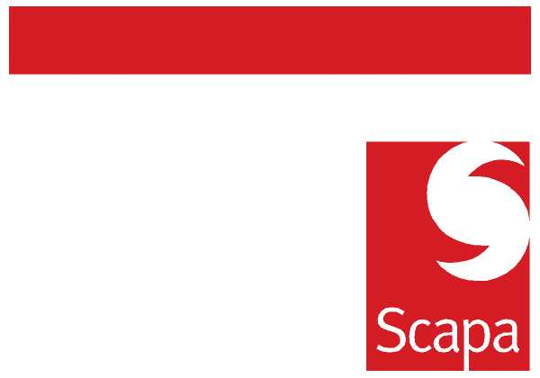

ANNOUNCEMENT

Industrial Business Unit and R&D Structure

I am pleased to announce that Dan Jeffery has accepted a position as Director of Application Engineering within the Industrial Business Unit in North America reporting to me. This position will be effective April 1st, and Dan and his family will be moving back to Windsor as early as possible.

Following Jim Ding’s resignation from the business Dan will also be assuming functional responsibility for the R&D / Technical team in North America on an interim basis. Given Dan’s familiarity with the North American team he is well suited for the interim role.

As most of you are aware Dan has spent the last 2 years managing the R&D team in Europe, in the prior 15 years he has had a variety of Technical and Commercial roles in Scapa, including managing the NA Automotive Business Unit.

Michael Muchin
Industrial Business Unit Manager North America

-----------------------------------------------------------------------------------------------------------

Following Jim Ding’s departure, I am pleased to announce that Isabelle Rouzeval will assume the role of R&D Manager Europe with functional responsibility for the R&D team in Europe as of 1st April, reporting to the undersigned. Isabelle has successfully managed the French R&D team for the last 2 years, and has been an integral part of the Valence site. She will maintain responsibility for the improvement plans in Valence through completion of first phase.

I am confident that Isabelle’s strong management, excellent technical background, along with her process orientation will be key in helping the European team deliver NPD and business growth. Please support her in her new role and join me in wishing her success in her new responsibilities.

Barry Andrew
European Commercial and Marketing Director

March 2, 2010

